**Measure II. Clinical Partners and Stakeholder Engagement and 2022-23**

The Division of Education is continuously involved with the following stakeholders and we actively engage in meetings, conferences, or activities, with each organization with a focus on continuous improvement.

|  |  |
| --- | --- |
| Name of Organization | Activities |
| Local School District Clinical Partners with MOU’s  Little Rock School District   * North Little Rock School District * Pulaski County Special School District * ScholarMade Achievement Place of Arkansas | Enhance established MOUs with cooperating and mentoring teachers.  Meet regularly with teachers and teacher candidates placed in the districts throughout the years. Make program changes based on feedback. |
| Forward Arkansas | Participate with Arkansas Forward Arkansas. This organization is dedicated to ensuring every Arkansas student has access to and is prepared for opportunities in life and a career in today's world. It is also creating programs to increase the number of licensed teachers in Arkansas. |
| Arkansas Council of Deans of Education | Participate in monthly meetings focused on improvement in Educator Preparation Programs. |
| Arkansas Teacher Licensure Division | Participate in professional development, program review, and statewide reporting. |
| Philander Smith College Council of Deans | Participate in bi-weekly meetings. |
| Arkansas House and Senate Committees on Education | Attend meetings, make suggestions, and propose legislative ideas to enhance teacher quality. |
| Arkansas Legislative Black Caucus Think Tank | Lead discussions regarding ways to improve teacher recruitment and teacher quality. |
| Arkansas Center for Innovation in Teaching Excellence (ACITE) | Collaboratively host conferences and meetings on teacher quality and Cultural Competency in Teaching. |
|  |  |
| Teach/Arkansas | Attend professional development and Arkansas Educator Signing Day at the State Capitol. |
| Arkansas Educator Rising Region 6 | Serve as a Region Six leader and work with aspiring educators who reflect the demographics of their communities and who are passionate about serving those communities through public education, conference planning, and competitions. |
| Philander Smith College Office of Recruitment | Work with the PSC Office of Recruitment to help recruit new students |
| Cooperating Teachers and Teacher Support Team | Meet with cooperating teachers regarding lesson plans, feedback and ways to improve program outcomes. |
| EPP Team and Adjunct Faculty | Meet regularly with EPP Team and adjunct faculty to enhance continuous improvement. |

**Key Findings:**

**Our Clinical partners and stakeholders provide invaluable service to our Division of Education.** These partnerships help us collaborate to achieve a common goal and help sharpen our focus on Teaching standards of excellence. Diverse Clinical l Partnerships help provide a clear focus on quality assurance and help us develop a theory of action and a target solution.  Mutually beneficial partnerships help guide the program's growth.  Clinical partnerships and stakeholder meetings help create a sustainable framework for our programs to succeed.

**An Example of a Stakeholder Agenda Meeting is attached:**

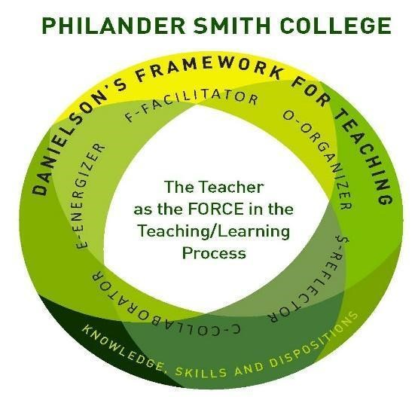

**Lesson Planning Agenda**

May 17, 2022

1. Mission of the Lesson Planning Committee
2. CAEP Standard I: The Learner and Learning
3. Clinical Experience Observational Instrument
4. Lesson and/or unit plans
5. Portfolios-specific portion dedicated to learner and learning
6. Taking Stock:
7. Lesson Planning Instrument and Rubric for Review
8. Approval of Lesson Plan
9. Lesson Planning and Student Achievement
10. Current Level of Student Performance
11. Planning for the Future
12. Professional Development for Education Staff on Lesson Plans
13. Professional Development for Students

Key Findings:

The EPP is focused on improving lesson planning. This is one of multiple meetings held with our EPP team partners, and cooperating teachers to enhance lesson planning.

Stakeholders: Cooperating Teachers.: The lesson plan translates the curriculum into clear daily goals for student learning that include a description of the objective and a way to measure the student’s attainment of stated goals.

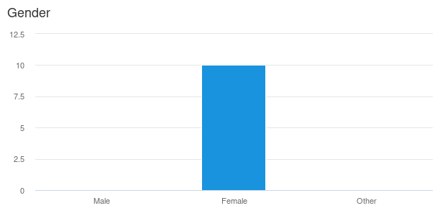

Table B: Ethnicity of Cooperating Teachers

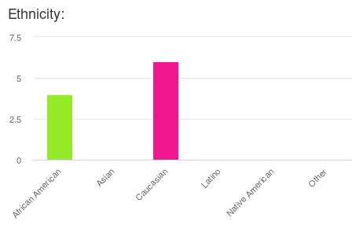

Table C: Years of Teaching Experience

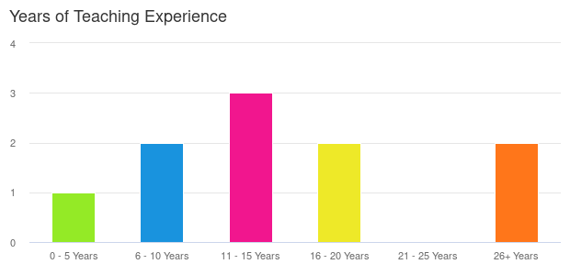

Table D: Grades Taught

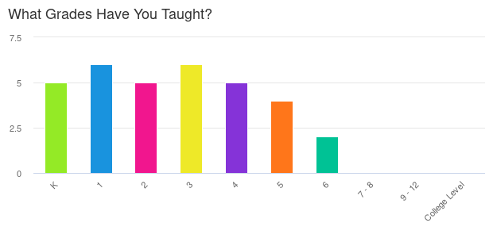

Table E: Percent Nationally Board Certified.

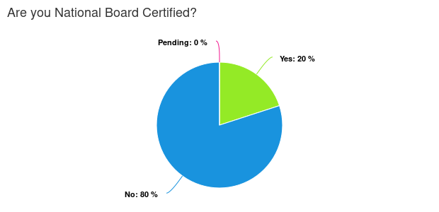

Table F: Educational Background

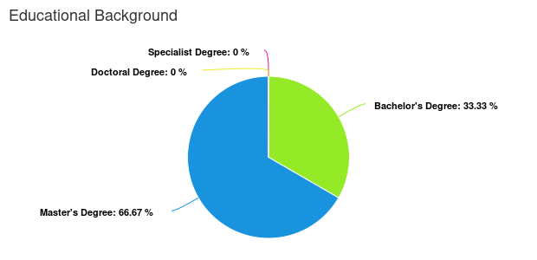

Cooperating Teacher Experience with PSC